
ENGREG HIGH SCHOOL
24, Bankole Street, Pedro, Shomolu, Lagos
SS 1 COMPUTER STUDIES SCHEME OF WORK
2024/2025 SESSION

FIRST TERM
WEEKS | TOPIC | SUB-TOPIC
ONE | Overview of Computer System I | Introduction, Definition, RAM and ROM
TWO | Overview of Computer System II | Characteristics of a computer
THREE | Historical Development of Computing Devices I (Pre-Computer Age to 19th Century) | Abacus, Napiers Bone, Pascaline
FOUR | Historical Development of Computing Devices II (Pre-Computer Age to 19th Century) | Herman Hollerith, Charles Babbage, Gottfried Leibniz
FIVE | Historical Development of Computing Devices III (20th Century to Date) | ENIAC, UNIVAC
SIX | Computer Input Devices I | Definition, Examples, Features
SEVEN | Computer Input Devices II | Mouse, Joystick, etc
EIGHT | Computer Output Devices I | Definition, Examples
NINE | Computer Output Devices II | Uses, Features
TEN | Data and Information | Definition, Examples, Differences between data and information
ELEVEN | Revision
TWELVE | Examination

ENGREG HIGH SCHOOL
24, Bankole Street, Pedro, Shomolu, Lagos
WEEK: 1 FIRST TERM SESSION: 2024/2025
SUBJECT: COMPUTER STUDIES |  | TOPIC: OVERVIEW OF COMPUTER SYSTEM
CLASS: SS 1 | DATE: 9th – 13th September, 2024 | REFERENCE BOOKS: New Computer Studies for SS 1 by J.O.E Otuka et al Pages 1-9  Online with computers for SS 1 by Adedapo F. O. et al 1 - 15
LEARNING PURPOSE:  To provide foundational knowledge on the computer and to learn how computers communicate information to the users. |  |  |  | LESSON PERIOD: 1  DURATION: 40 MINS
LEARNING OBJECTIVE: By the end of the lesson, students will be able to:  - Define Computer.  - Explain the concept of IPOS  - State the components of a computer system |  |  |  | KEYWORDS:  Computer, Components, Hardware, Software, ROM, RAM.
PREVIOUS LEARNING: The students are familiar with the computer. |  | INSTRUCTIONAL MATERIALS:  Interactive board, computer system, Internet
LEARNING ACTIVITIES IN STEPS:  Step 1: The teacher marks assignment and makes correction.  Step 2: The teacher asks questions on previous knowledge  Step 3: The teacher modifies students’ response and introduces the new topic  Step 4: Students would be taken through the derailed explanation of the lesson content  Step 5: Students ask questions on the content of the lesson  Step 6: Students would be evaluated based on behavioural objectives  Step 7: Students Assignments are given and notes and marked |  |  | LEARNING TIME FOR EACH STEP:  Step 1: 3mins  Step 2: 2mins  Step 3: 3mins  Step 4: 20mins  Step 5: 2mins  Step 6: 7mins  Step 7: 3mins
LEARNING SKILLS:  Critical thinking, creative thinking, communicating and leadership development |  | ACTIVITY  - Define Computer.  - State the three components of a computer system.
EVALUATIVE QUESTIONS:  - Define Computer.  - Explain the concept of IPOS  - State the three components of a computer system |  | ASSIGNMENT  Explain  - Input  - Process  - Output
OVERVIEW OF COMPUTER SYSTEM
Definition of a Computer
A computer can be defined as an electronic device which under the control of a stored program accepts data, stores the data, processes the data and brings out the results as meaningful information.
COMPUTER AS AN IPOS SYSTEM
Computer performs 4 key operations.
a. Input b. Processing c. Output d. Storage
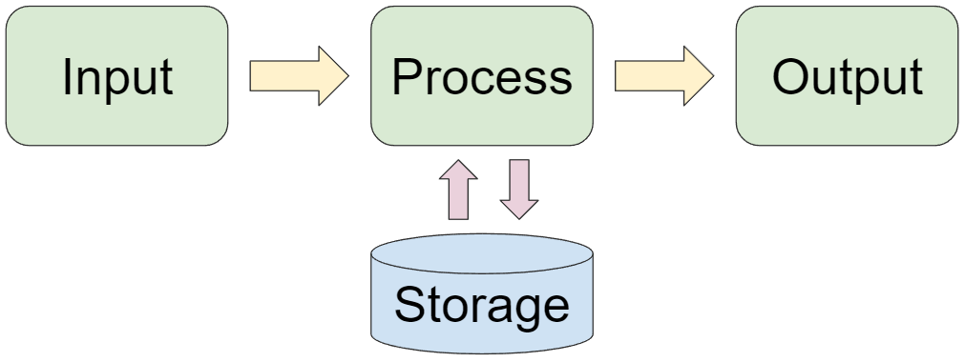
- Input: Data are entered into the computer through the input unit. Data are raw facts that are to be processed into meaningful form.
- Processing: Computer performs certain operations on data entered into it; the Central Processing Unit (CPU) handles this operation.
- Output: The result of what has been processed will be displayed by the output device such as the monitor.
- Storage: Inputted data and processed information are stored in the memory and permanent storage on the computer.
CONSTITUENTS/COMPONENTS OF A COMPUTER SYSTEM
There are 3 main constituents of the computer system, these are:
- The Hardware
- The Software
- The Humanware/Peopleware

ENGREG HIGH SCHOOL
24, Bankole Street, Pedro, Shomolu, Lagos
WEEK: 1 FIRST TERM SESSION: 2024/2025
SUBJECT: COMPUTER STUDIES |  | TOPIC: OVERVIEW OF COMPUTER SYSTEM
CLASS: SS 1 | DATE: 9th – 13th September, 2024 | REFERENCE BOOKS: New Computer Studies for SS 1 by J.O.E Otuka et al Pages 1-9  Online with computers for SS 1 by Adedapo F. O. et al 1 - 15
LEARNING PURPOSE:  To provide foundational knowledge on the computer and to learn how computers communicate information to the users. |  |  |  | LESSON PERIOD: 2  DURATION: 40 MINS
LEARNING OBJECTIVE: By the end of the lesson, students will be able to:  - Define Hardware  - Explain the hardware components.  - Explain the functions of the CPU components. |  |  |  | KEYWORDS:  Computer, Components, Hardware, Software, ROM, RAM.
PREVIOUS LEARNING: The students are familiar with the computer. |  | INSTRUCTIONAL MATERIALS:  Interactive board, computer system, Internet
LEARNING ACTIVITIES IN STEPS:  Step 1: The teacher marks assignment and makes correction.  Step 2: The teacher asks questions on previous knowledge  Step 3: The teacher modifies students’ response and introduces the new topic  Step 4: Students would be taken through the derailed explanation of the lesson content  Step 5: Students ask questions on the content of the lesson  Step 6: Students would be evaluated based on behavioural objectives  Step 7: Students Assignments are given and notes and marked |  |  | LEARNING TIME FOR EACH STEP:  Step 1: 3mins  Step 2: 2mins  Step 3: 3mins  Step 4: 20mins  Step 5: 2mins  Step 6: 7mins  Step 7: 3mins
LEARNING SKILLS:  Critical thinking, creative thinking, communicating and leadership development |  | ACTIVITY  - Define Hardware  - Explain the three functions of the CPU components.
EVALUATIVE QUESTIONS:  - Define Hardware  - Explain the four hardware components.  - Explain the three functions of the CPU components. |  | ASSIGNMENT  Explain and give two examples.  - Input devices  - Processing Devices  - Output Devices  - Storage Devices.

HARDWARE
Computer hardware consists of the physical components required to perform tasks and execute software.

HARDWARE COMPONENTS
The computer hardware components can be classified as:
Input Devices: Input devices provide data and control signals to a computer. Examples include: Keyboard, Mouse, Scanner, Microphone, Webcam, Joystick, Touchscreen
Output Devices: Output devices translate data from the computer into a form humans can understand. Examples include: Monitor, Printer, Speaker, Projector, Headphones
Storage Devices: Storage devices store data permanently or temporarily. Examples include: Hard Disk Drive (HDD), CDs, DVDs, USB, Flash Drive, Memory Card
Processing Devices: Processing devices interpret and execute instructions. The CPU, considered the brain of the computer, includes: CPU, Motherboard, Sound Card, Network Card
CPU Components: - The CPU is divided into three main parts:
Control Unit (CU)
- Fetches, decodes, and directs instructions.
- Manages data flow between the CPU, memory, and input/output devices.
Arithmetic and Logic Unit (ALU)
- Executes arithmetic operations (addition, subtraction, multiplication, division).
- Performs logical operations (AND, OR, NOT, XOR) and comparisons.
Memory Unit
- Stores data and instructions temporarily or permanently.
- Facilitates quick data access for the CPU.
Main memory includes:
Random Access Memory (RAM): Volatile, temporary storage for active tasks.
Read-Only Memory (ROM): Non-volatile, permanent storage for essential firmware.

